Project Design Phase Solution Architecture
Date | 11-2-2026
Team ID | LTVIP2026TMIDS82938
Project Name | ShopEZ : One-Stop Shop For Online Purchases
Maximum Marks | 4 Marks
Solution Architecture:
ShopEZ’s architecture uses the MERN stack :
- MongoDB – NoSQL database to store users, products, orders, etc. • Express.js & Node.js – Backend RESTful API handling business logic, authentication, and admin tools.
- React.js – Frontend application providing dynamic, responsive user interfaces for customers, sellers, and admins.

Key Features
- JWT-based secure login
- Role-based access: Customer, Seller, Admin
- Real-time product inventory management
- Responsive UI using React & Tailwind/Bootstrap
- Modular backend API
- Admin dashboard for monitoring users, orders, and product analytics

Development Phases
- Phase 1 – User authentication and role-based routing
- Phase 2 – Customer UI: product browsing, cart, checkout 3.
Phase 3 – Seller dashboard: add/update products, view orders 4.
Phase 4 – Admin dashboard: view users, manage platform 5 .
Phase 5 – Payment gateway integration (future scope) Architecture Diagram
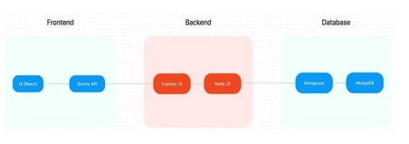
Roles :
- Customer → Browse ➝ Cart ➝ Checkout
- Seller → Dashboard ➝ Manage Products ➝ View Orders •
Admin → Monitor users, sellers, products, and system logs

